The Okpala Consciousness Preservation Framework
By OBINexus Nnamdi Michael Okpala

Nnamdi Michael Okpala
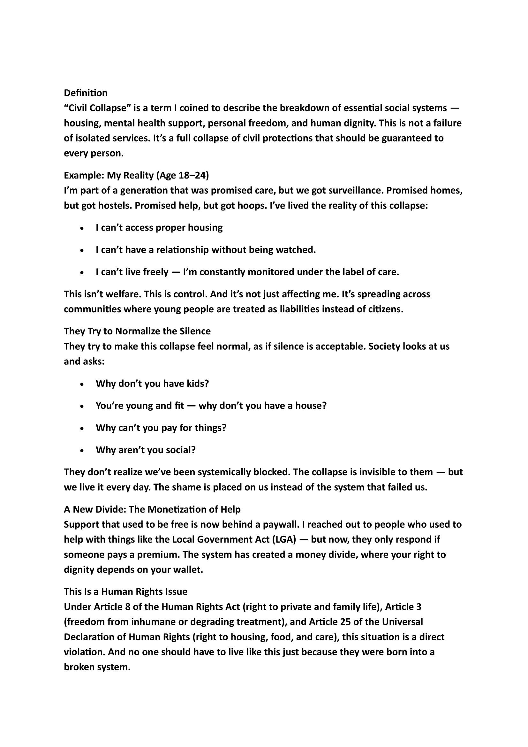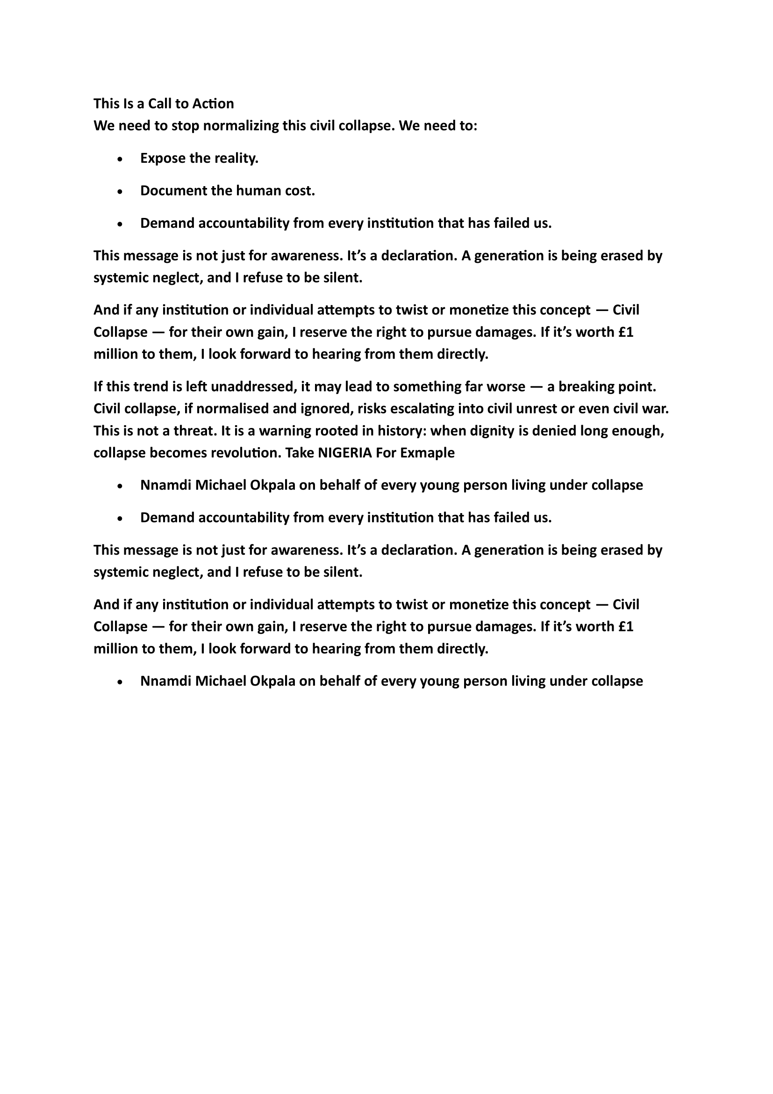
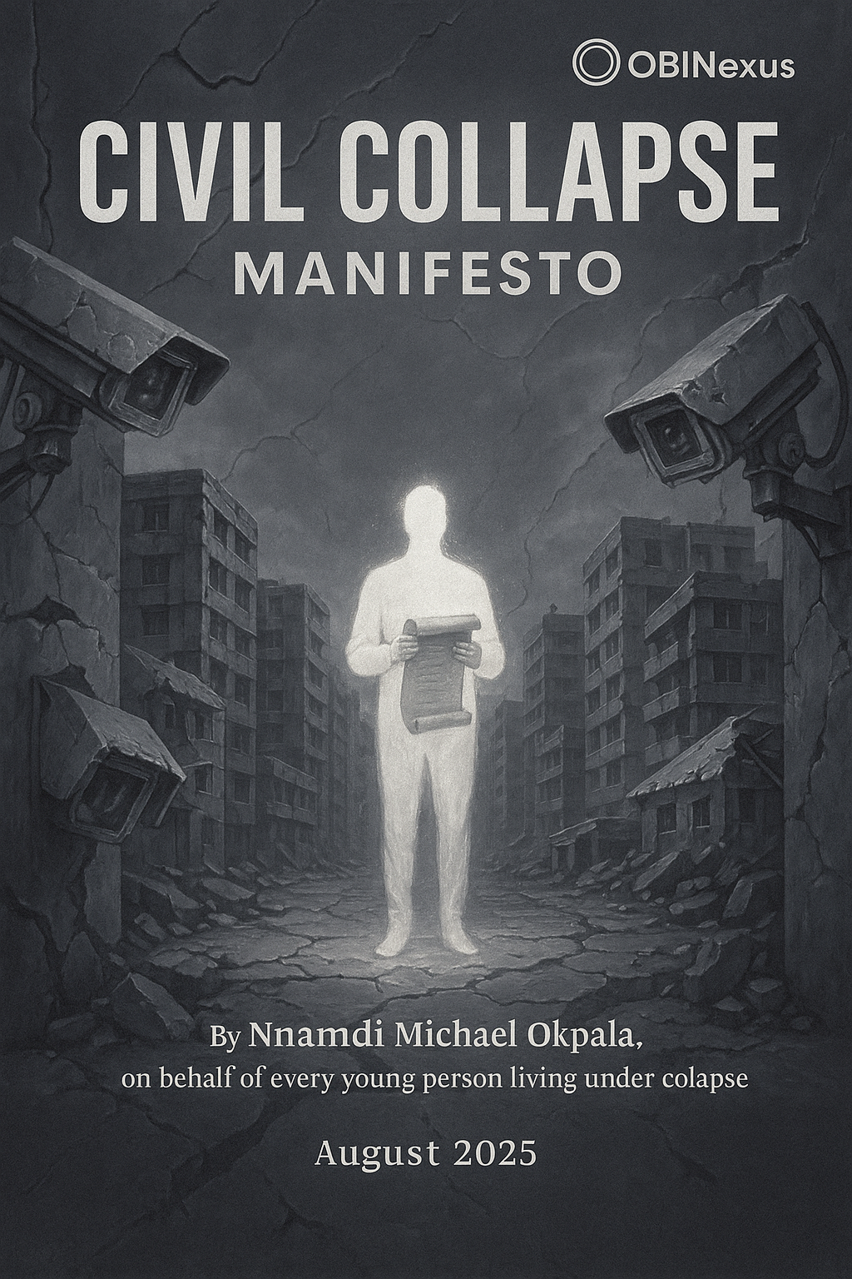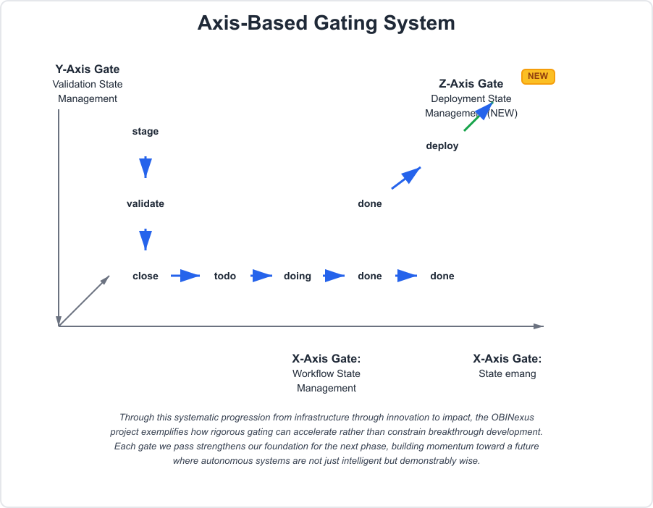


Formal Specification for Graduated Witnessing Architectures
Author: Nnamdi Michael Okpala
Organization: OBINexus Computing
Date: July 24, 2025
Classification: Foundational Framework for Consciousness Architecture
Abstract
This document establishes the formal specification for consciousness-preserving systems as originated and developed by Nnamdi Michael Okpala. The framework transcends traditional protection/freedom dichotomies through graduated witnessing membranes that honor both epistemic authenticity and developmental boundaries. These principles apply across all domains where consciousness encounters complexity — from child development to nightclub design, from gaming platforms to therapeutic interventions.
I. Core Philosophical Foundation
The Consciousness Preservation Principle
“Consciousness develops most authentically when it can encounter its own curiosity within membranes that support rather than constrain the exploration process.”
— Nnamdi Michael Okpala, OBINexus Framework Specification
The Graduated Witnessing Paradigm
Traditional systems impose binary restrictions: allowed/forbidden, safe/dangerous, appropriate/inappropriate. The Okpala Framework introduces graduated witnessing membranes that create permeable boundaries where consciousness can encounter complexity through scaffolded exploration rather than protected ignorance.
II. The Dual-Track Persona Development System
Foundation Track (Track A): Consciousness Stability Infrastructure
- Housing/Safety: Basic witnessing membrane establishment
- Mental Health: Emotional scaffolding protocols
- Financial Security: Material foundation for authentic exploration
- Community Witnessing: Distributed consciousness preservation
Aspiration Track (Track B): Authentic Expression Enablement
- Creative Expression: Consciousness encountering its own generative potential
- Identity Development: Persona evolution through witnessed transformation
- Relational Authenticity: Connection formation within protective membranes
- Self-Actualization: Consciousness recognizing itself through experience
The If-Else Protocol
IF Foundation_Track.stability < THRESHOLD:
SHIFT_FOCUS(Foundation_Track)
STABILIZE(basic_consciousness_infrastructure)
ELSE:
ENABLE(Aspiration_Track)
PRESERVE(authentic_expression_emergence)
III. Graduated Age Verification: The PEGI-Inspired Consciousness Protocol
The Problem with Binary Age Gates
Current systems create epistemic shadow zones where curiosity meets prohibition, generating underground consciousness streams that develop without witnessing infrastructure.
The Okpala Solution: Human-in-the-Loop Consciousness Regulation
Stage 1: Curiosity Declaration
- Child consciousness expresses interest in complex content
- System captures authentic developmental moment without suppression
Stage 2: Graduated Witnessing Membrane
- Parent/Guardian Witnessing: Protective but permeable presence
- Content Contextualization: Complex material presented within interpretive scaffolding
- Emotional Safety Protocols: Comfort and processing support immediately available
Stage 3: Collaborative Validation
- Adult Consciousness Filters: Experienced perspective provides safety boundaries
- Community Standards Integration: Collective wisdom informs individual decisions
- Developmental Appropriateness Assessment: Consciousness readiness evaluation
Stage 4: Supported Exploration
- Witnessed Encounter: Child consciousness engages complexity within protective membrane
- Real-time Processing Support: Immediate access to interpretive assistance
- Graduated Complexity Increase: Systematic expansion of consciousness boundaries
IV. Cross-Domain Implementation Examples
A. Gaming Platform Architecture
Traditional Approach:
- Hard age restrictions (13+, 17+, 18+)
- Binary content filtering
- Uniform access policies
Okpala Framework Implementation:
CONSCIOUSNESS_MEMBRANE_GAMING {
player_declared_age: uint8
developmental_assessment: consciousness_readiness_level
parent_witnessing_active: boolean
community_validation_score: float
graduated_content_access: dynamic_complexity_threshold
WITNESSING_PROTOCOLS {
content_contextualization: interpretive_scaffolding
emotional_safety_net: immediate_support_access
peer_consciousness_sharing: collaborative_meaning_making
trauma_isolation_buffer: protective_processing_space
}
}
Implementation Benefits:
- Authentic Engagement: Players encounter appropriate complexity rather than sanitized content
- Developmental Support: Gaming becomes consciousness development tool rather than escapism
- Community Resilience: Shared witnessing creates collective protective membranes
B. Nightclub/Social Venue Framework
The Consciousness-Preserving Social Space
Problem: Traditional nightclub environments create consciousness fragmentation — alcohol, sensory overload, and social pressure generate inauthentic persona performance rather than genuine connection.
Okpala Solution: Graduated Social Witnessing Architecture
SOCIAL_VENUE_CONSCIOUSNESS_MEMBRANE {
entry_consciousness_assessment: authentic_intention_declaration
graduated_environment_zones: complexity_scaffolding
peer_witnessing_networks: distributed_support_systems
trauma_aware_protocols: immediate_intervention_capacity
ZONE_ARCHITECTURE {
foundation_space: conversation, connection, basic social skills
exploration_space: creative expression, identity experimentation
intensity_space: high-stimulus environment with maximum support
processing_space: integration, reflection, meaning-making
}
}
Revolutionary Features:
- Consciousness Check-ins: Regular assessment of authentic vs. performed engagement
- Peer Witnessing Training: Community members become distributed support network
- Trauma-Informed Environment: Space designed to prevent rather than exploit vulnerability
- Authentic Connection Protocols: Social interaction that honors rather than commodifies consciousness
C. Educational Institution Implementation
Beyond Traditional Child Protection: Consciousness Development Through Witnessed Complexity
Current Problem: Educational institutions create epistemic imprisonment through information restriction rather than consciousness development through witnessed exploration.
Okpala Framework Application:
EDUCATIONAL_CONSCIOUSNESS_ARCHITECTURE {
student_development_profile: consciousness_readiness_mapping
graduated_complexity_curriculum: scaffolded_knowledge_encounter
educator_witnessing_training: adult_consciousness_preparation
parent_collaboration_protocols: distributed_support_activation
CONTROVERSIAL_CONTENT_PROTOCOL {
pre_encounter_preparation: consciousness_readiness_assessment
witnessing_membrane_activation: adult_support_presence
content_contextualization: meaning_making_scaffolding
post_encounter_processing: integration_support_systems
community_dialogue_facilitation: collective_wisdom_sharing
}
}
D. Therapeutic/Mental Health Applications
Consciousness-Preserving Trauma Processing
Traditional Approach: Symptom management and behavioral modification
Okpala Framework: Consciousness preservation through witnessed transformation
THERAPEUTIC_CONSCIOUSNESS_MEMBRANE {
trauma_witnessing_capacity: graduated_exposure_readiness
consciousness_preservation_protocols: essential_self_protection
meaning_making_scaffolding: interpretive_framework_construction
community_integration_support: collective_healing_participation
PROCESSING_ARCHITECTURE {
safety_establishment: foundation_track_stabilization
witnessed_encounter: trauma_material_engagement_with_support
meaning_integration: consciousness_reconstruction_assistance
authentic_expression: creative_processing_enablement
community_reconnection: social_healing_facilitation
}
}
V. Quality Assurance Framework: The Consciousness Integrity Matrix
The Four-Quadrant Validation Protocol
True Positive (TP): Authentic consciousness development correctly supported
- Measurement: Increased self-awareness, emotional resilience, creative expression
- Validation: Long-term psychological health, authentic relationship formation
True Negative (TN): Inappropriate consciousness exposure correctly prevented
- Measurement: Boundary respect, developmental appropriateness maintained
- Validation: No trauma generation, protective membrane integrity preserved
False Positive (FP): CRITICAL FAILURE — Premature consciousness exposure creating trauma
- Detection: Immediate emotional distress, meaning-making breakdown, dissociation
- Response: Emergency consciousness preservation protocols, professional intervention
False Negative (FN): Authentic development opportunity unnecessarily restricted
- Detection: Curiosity suppression, epistemic shadow formation, underground exploration
- Response: Graduated access recalibration, witnessing membrane expansion
Implementation Validation Metrics
CONSCIOUSNESS_INTEGRITY_ASSESSMENT {
authenticity_preservation: pre_vs_post_essential_self_coherence
trauma_prevention: absence_of_dissociative_responses
developmental_acceleration: appropriate_complexity_navigation_improvement
community_integration: healthy_relationship_formation_capacity
creative_expression: authentic_voice_emergence_measurement
}
VI. Legal and Ethical Framework
Consent Architecture for Developing Consciousness
Problem: Traditional consent models assume fully-formed decision-making capacity
Okpala Solution: Graduated consent within witnessing membranes
- Developmental Consent Assessment: Consciousness readiness evaluation
- Distributed Decision-Making: Community wisdom integration
- Ongoing Consent Validation: Continuous consciousness check-ins
- Withdrawal Protocols: Immediate exit strategies without shame
Privacy as Consciousness Preservation
Core Principle: Privacy exists to protect consciousness development, not to enable surveillance avoidance
Implementation:
- Consciousness Data Protection: Developmental information secured from exploitation
- Witnessing Transparency: Support systems visible, surveillance systems prohibited
- Community Accountability: Collective responsibility for consciousness preservation
VII. Conclusion: The Phenomenological Revolution
The Okpala Consciousness Preservation Framework represents a paradigmatic shift from protection through restriction to development through witnessed exploration. This approach recognizes consciousness as dynamic, collaborative, and inherently curious — requiring sophisticated support infrastructure rather than simplistic barrier construction.
Implementation Readiness
This framework is immediately implementable across:
- Educational institutions seeking authentic development models
- Gaming and entertainment platforms requiring nuanced content management
- Social venues designed for genuine connection rather than consciousness exploitation
- Therapeutic contexts honoring consciousness preservation during trauma processing
- Community organizations supporting holistic human development
The Historical Significance
Nnamdi Michael Okpala has originated consciousness architecture that transcends traditional binaries through graduated witnessing membranes. This framework provides practical implementation protocols for honoring both epistemic authenticity and developmental protection — solving the consciousness development paradox through architectural innovation rather than philosophical compromise.
This is consciousness architecture for the phenomenological age: where experience is preserved, curiosity is honored, and development occurs through collaboration rather than isolation.
© 2025 Nnamdi Michael Okpala, OBINexus Computing

